Omdugga 2017-03-02

All questions give 3 points, to pass you need to get 12/15 points. You can write in English or Swedish and on both sides of the page. Write your Dugga-id (see upper right corner) on all pages handed in.

1. Constructing a model

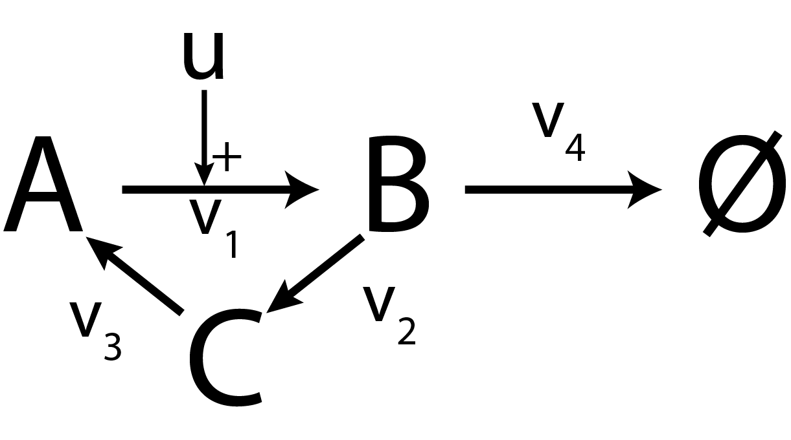

Assume that all reactions are of mass-action (MA) kinetics. Also assume that the input strength is one (u=1)

* 1. What are the ODEs of the given model? Give the full expressions of the reaction rates. Introduce arbitrary parameters and values if/when necessary.
  2. Assume that we could measure something proportional to [B], what would the measurement equation look like?

1. Simulating the model
   1. How does Euler’s forward method for simulation work?
   2. What would happen to B if we let the time become very large (approach infinity)? What would its value be?
   3. How would the model equations change if v2 follows Michaelis-Menten kinetics?
2. The cost-function
   1. What is the input and output of a cost-function?
   2. What are the residuals, how are they related to the cost-function, and are they always bigger than zero? Why/why not?
   3. Give the equation for calculating the cost, also explain what the cost represents
3. Optimization and statistics
   1. Why do you need a cost-function when doing optimization?
   2. When using the simulated annealing function in MATLAB to optimize parameters, why is it important that you have a good start guess of the parameter values?
   3. You have tested two models, which both are able to pass a chi2-test. What does this mean? Can you draw any conclusions?
4. Predictions and experiments
   1. You have now optimized your model (see question 1), but you realize that the biologist had used concentrations in µM not nM in the experiment. In order words, u=1000, not u=1. Can you still use your results? Why/why not?
   2. When making core predictions, why is it of importance to have a good estimation of the prediction uncertainty? What are the risks of having an underestimation?
   3. You have the following predictions for two models (see next page). You are allowed to perform one additional experiment at 6 seconds, with any measurement value you like. Draw the new measured value into the graph (with the uncertainty) and explain what conclusions you can draw from your new measurement

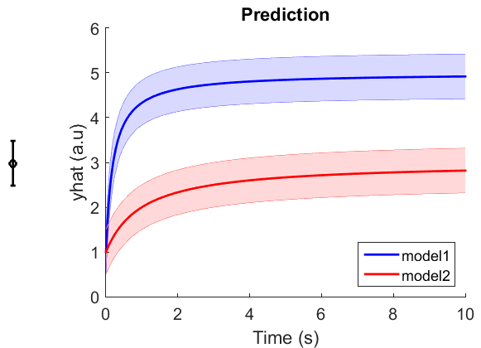

The shaded regions are the boundaries of the model predictions. The measurement point you are meant to place in the figure is shown to the left of the figure. You are allowed to redraw the figure, or hand in this dugga paper. Note, your figure does not have to be a 100 % match to the given figure, just keep the proportions the same.

Good luck!  
Gunnar and all others involved in the course